Inquiry Process: Bibliographic Information

Identify Bibliographic Information - Book
Bibliographic information is important because it tells your audience where you got your information and allows them to find that source themselves. Look at the following examples and circle the information that you need to cite the source.

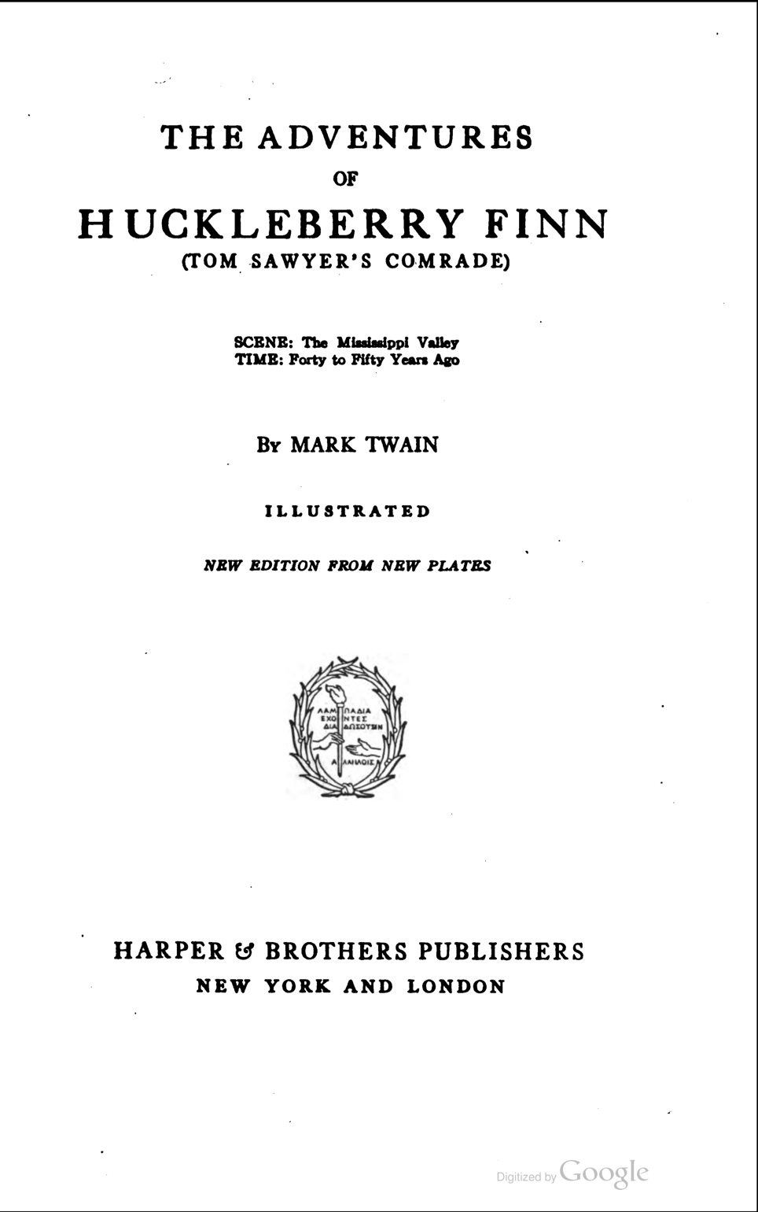

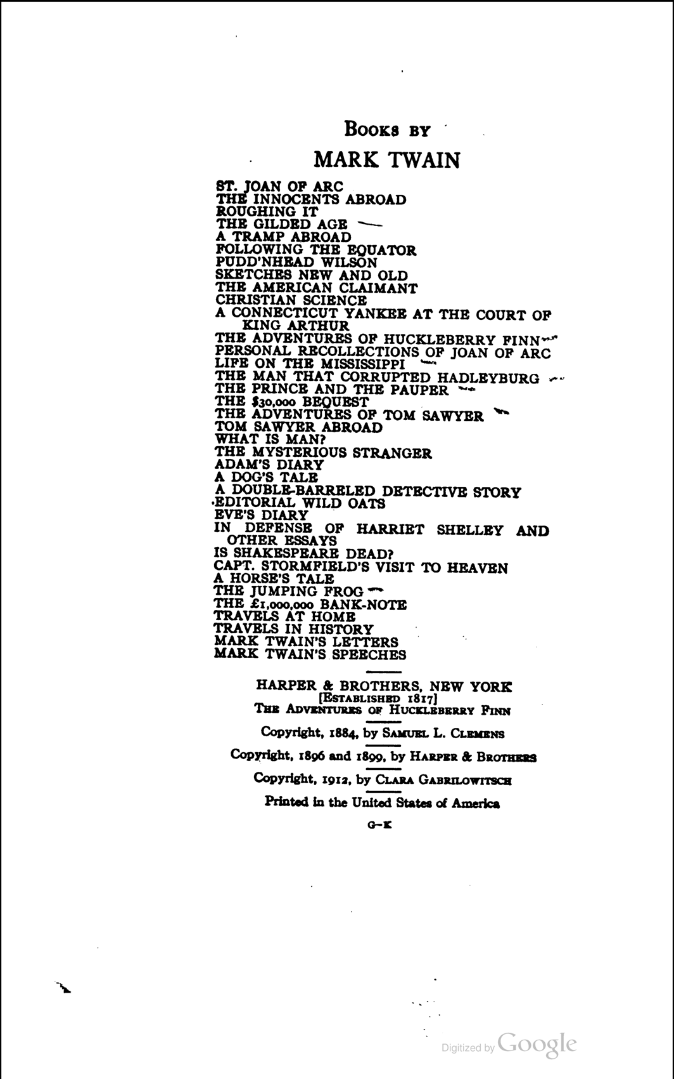

Write the MLA citation below:

Identify Bibliographic Information - Diagram
Bibliographic information is important because it tells your audience where you got your information and allows them to find that source themselves. Look at the following examples and circle the information that you need to cite the source.

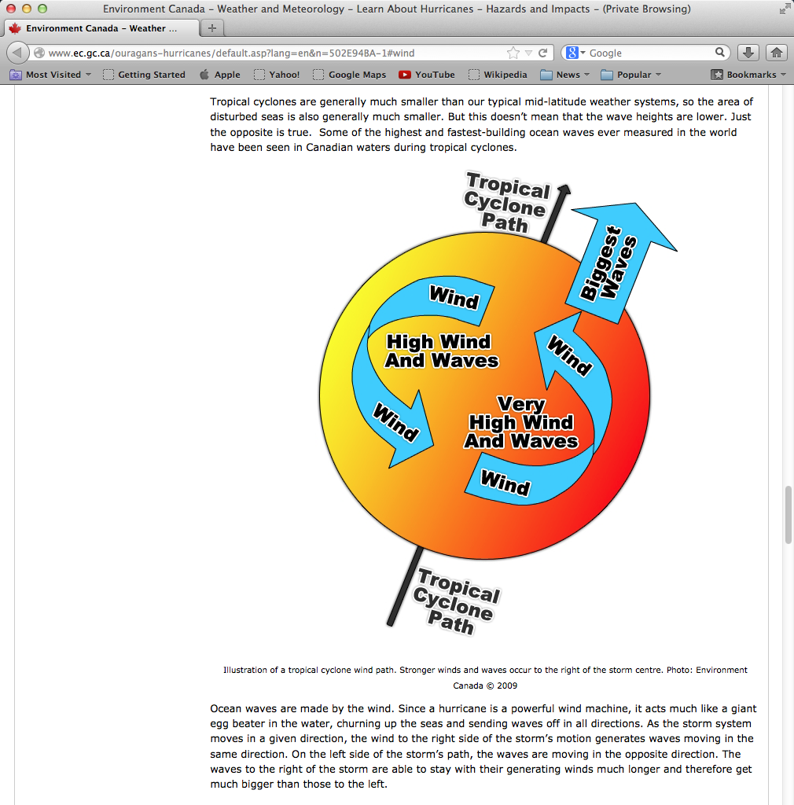

Write the MLA citation below:

Identify Bibliographic Information - eBook
Bibliographic information is important because it tells your audience where you got your information and allows them to find that source themselves. Look at the following examples and circle the information that you need to cite the source.

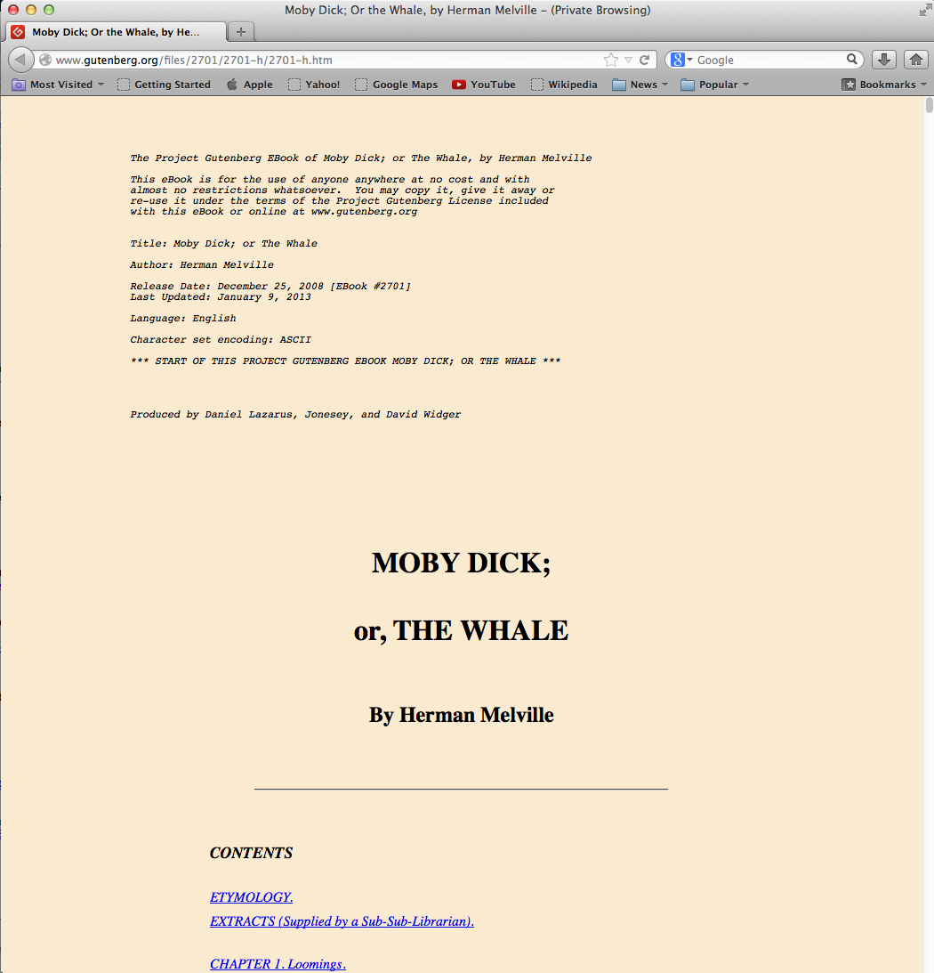

Write the MLA citation below:

Identify Bibliographic Information – Encyclopedia (online)
Bibliographic information is important because it tells your audience where you got your information and allows them to find that source themselves. Look at the following examples and circle the information that you need to cite the source.

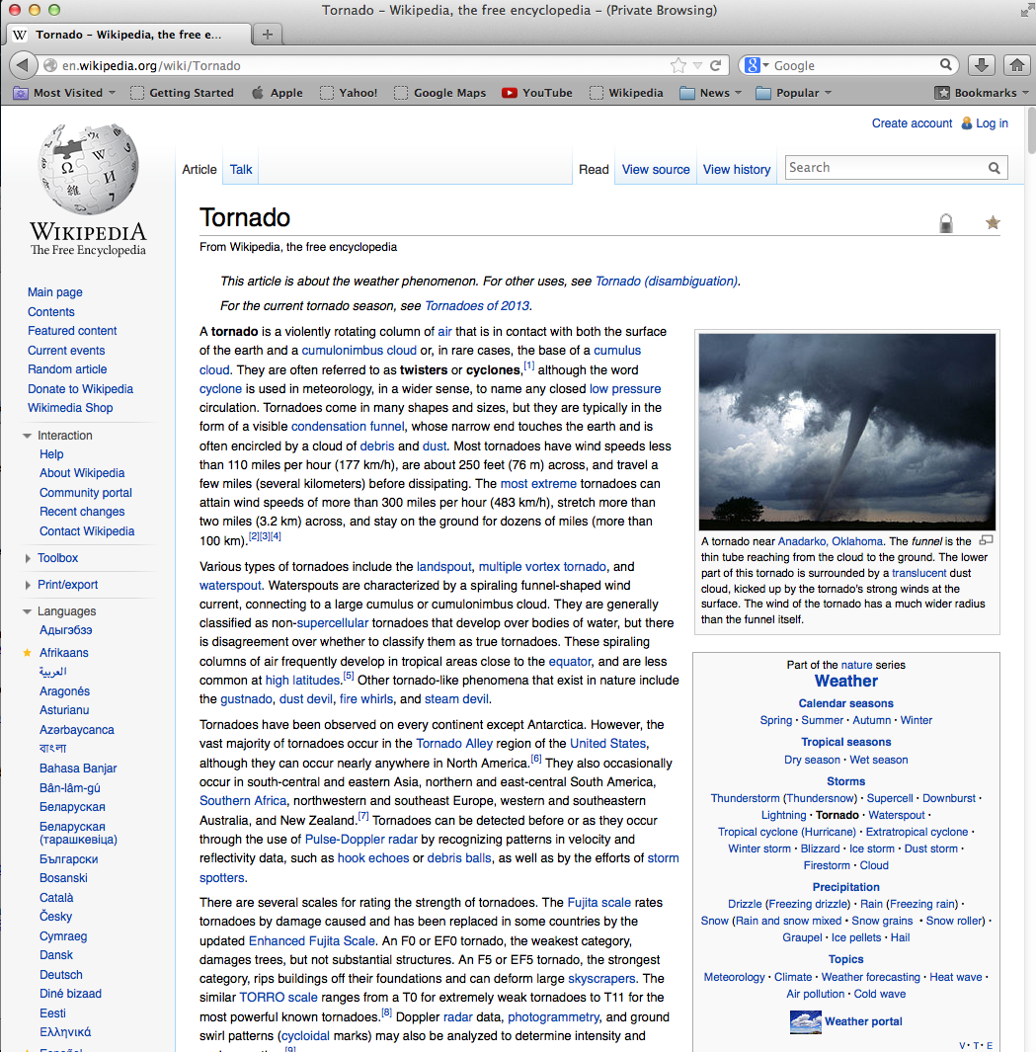

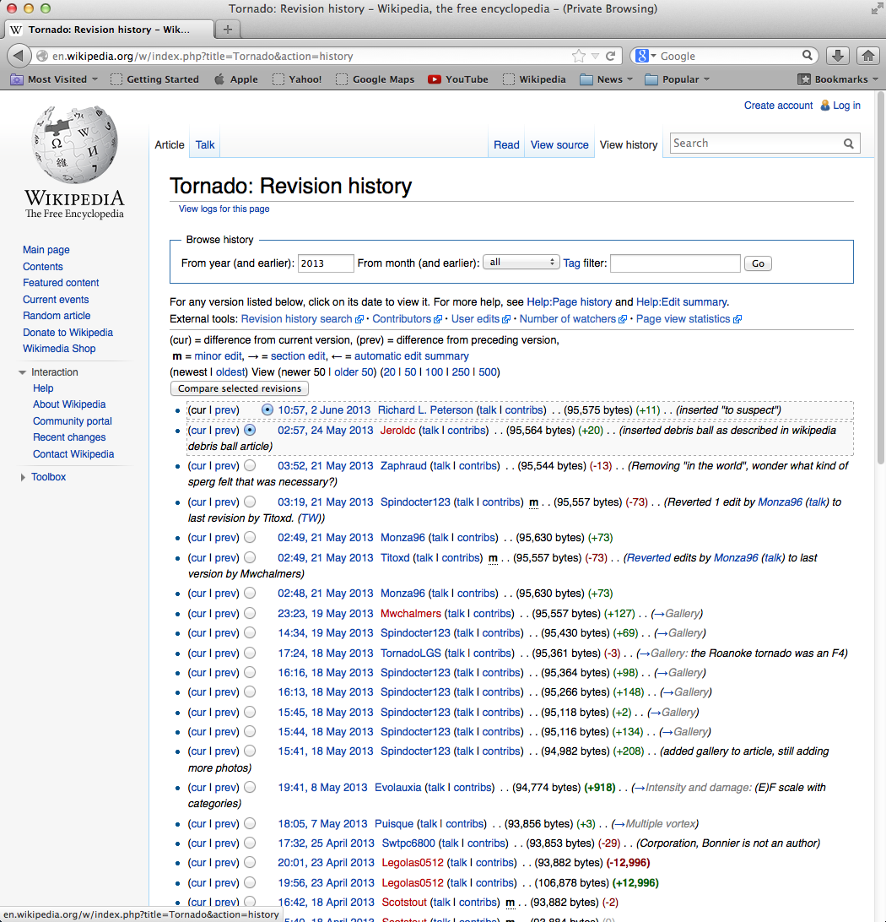

Write the MLA citation below:

Identify Bibliographic Information – Image
Bibliographic information is important because it tells your audience where you got your information and allows them to find that source themselves. Look at the following examples and circle the information that you need to cite the source.

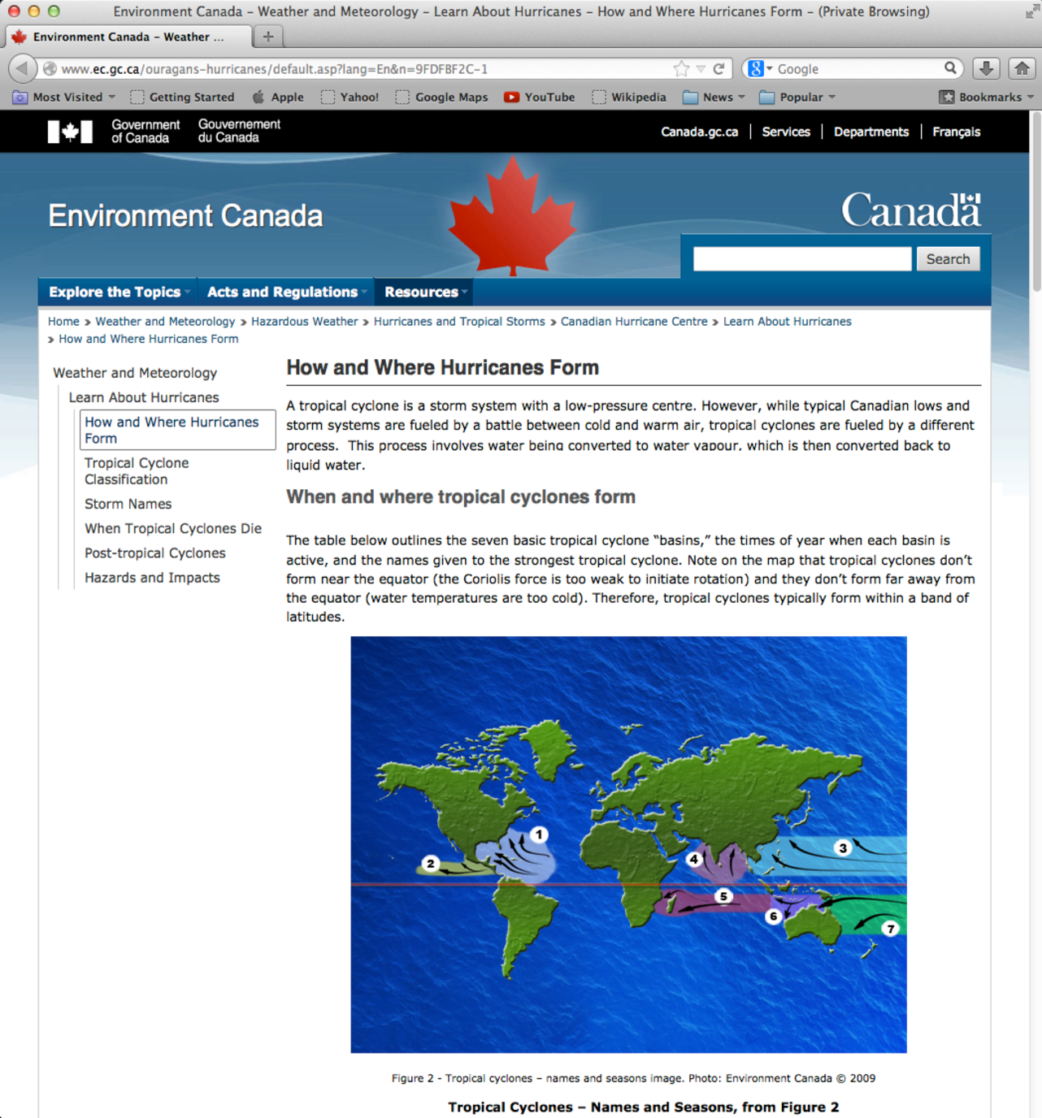

Write the MLA citation below:

Identify Bibliographic Information – Web Page
Bibliographic information is important because it tells your audience where you got your information and allows them to find that source themselves. Look at the following examples and circle the information that you need to cite the source.

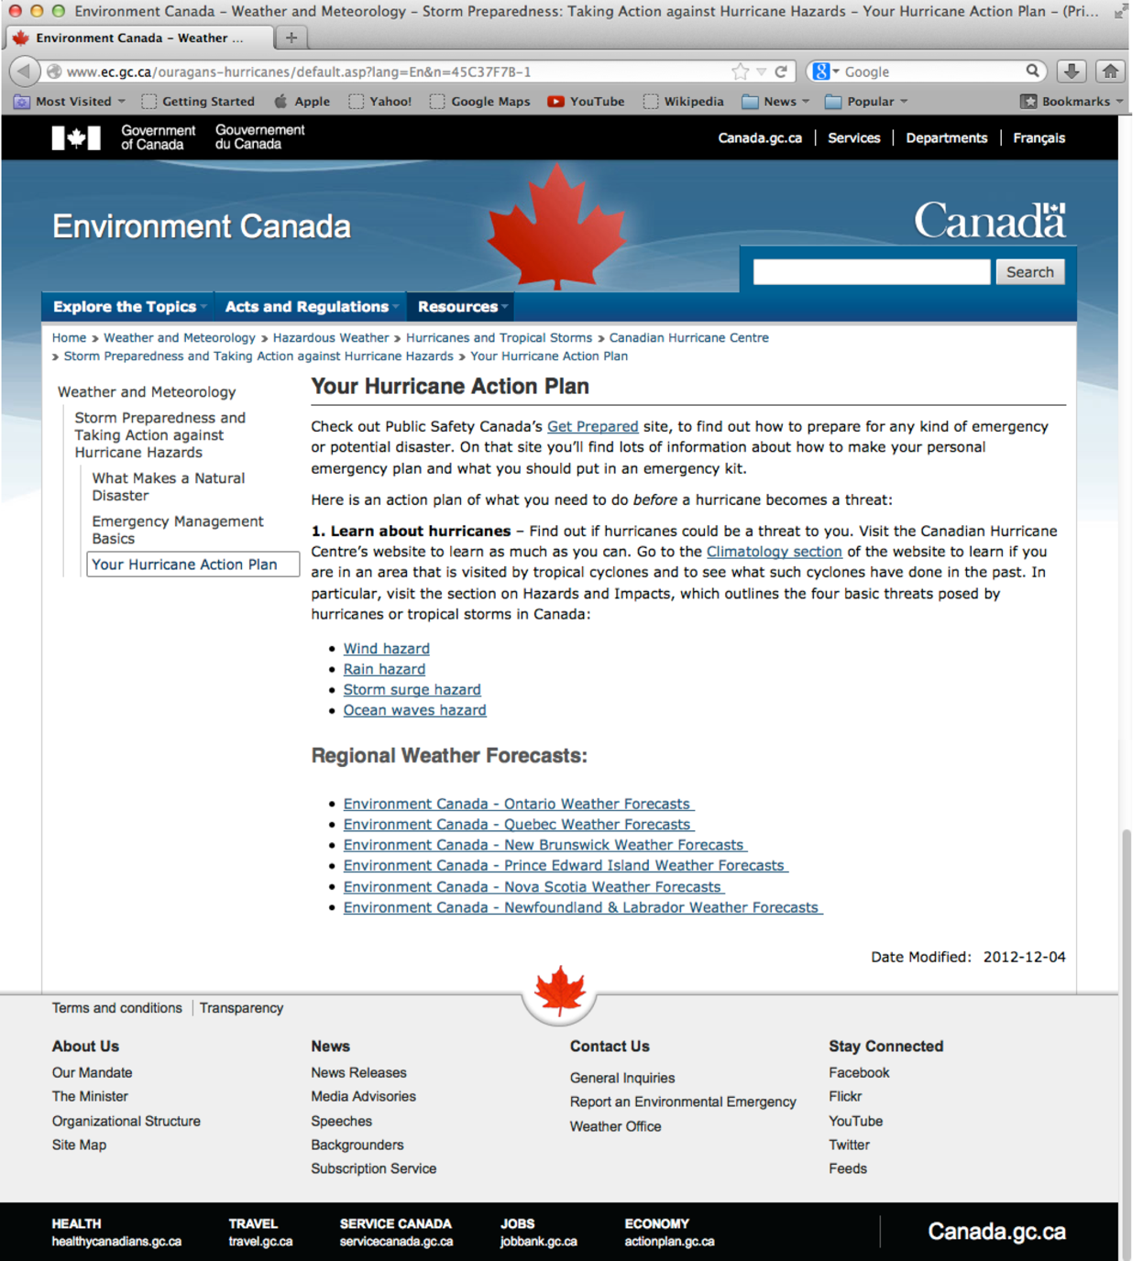

Write the MLA citation below:

Answer Key

Identify Bibliographic Information - Book

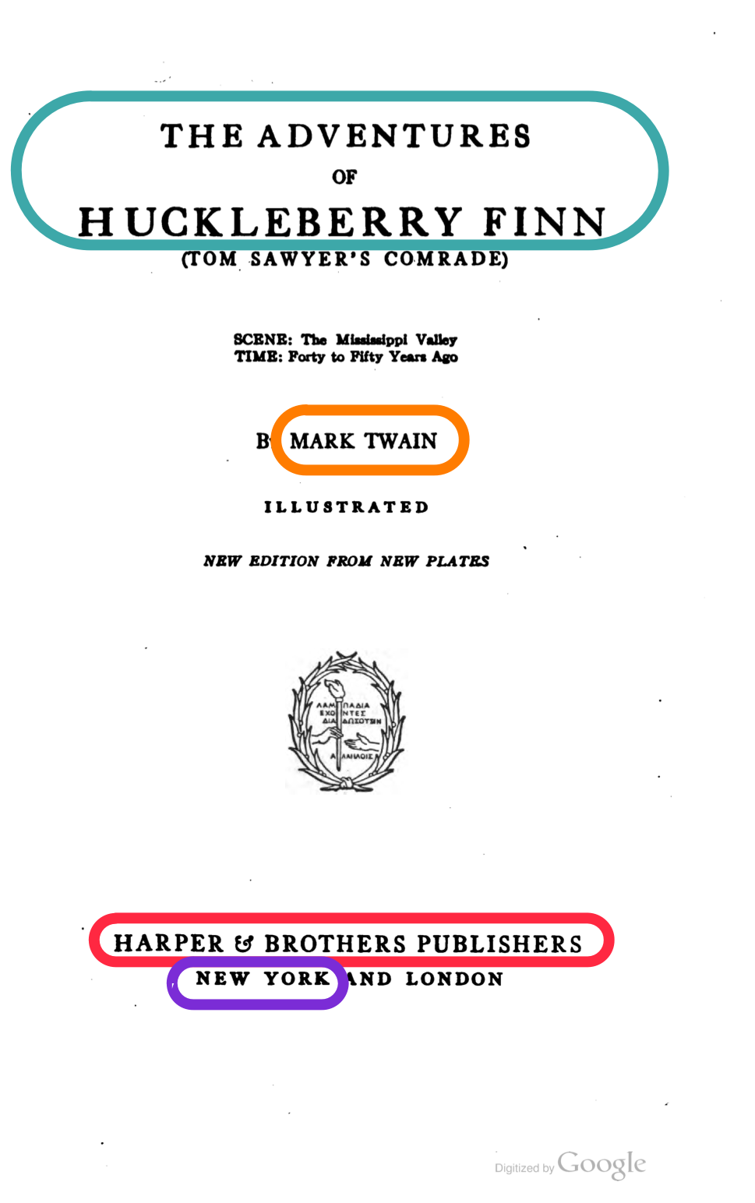

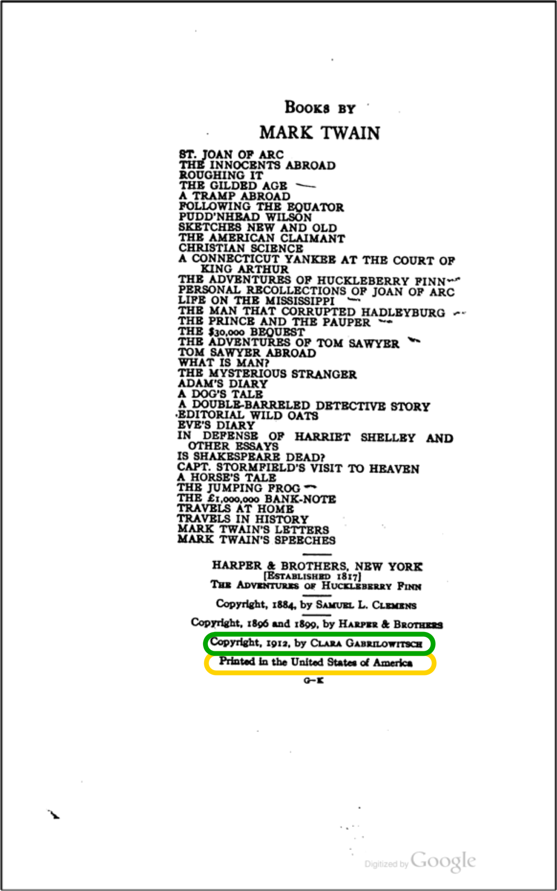

Twain, Mark. The Adventures of Huckleberry Finn. New York: Harper & Brothers, 1912. Print.

Identify Bibliographic Information – Diagram
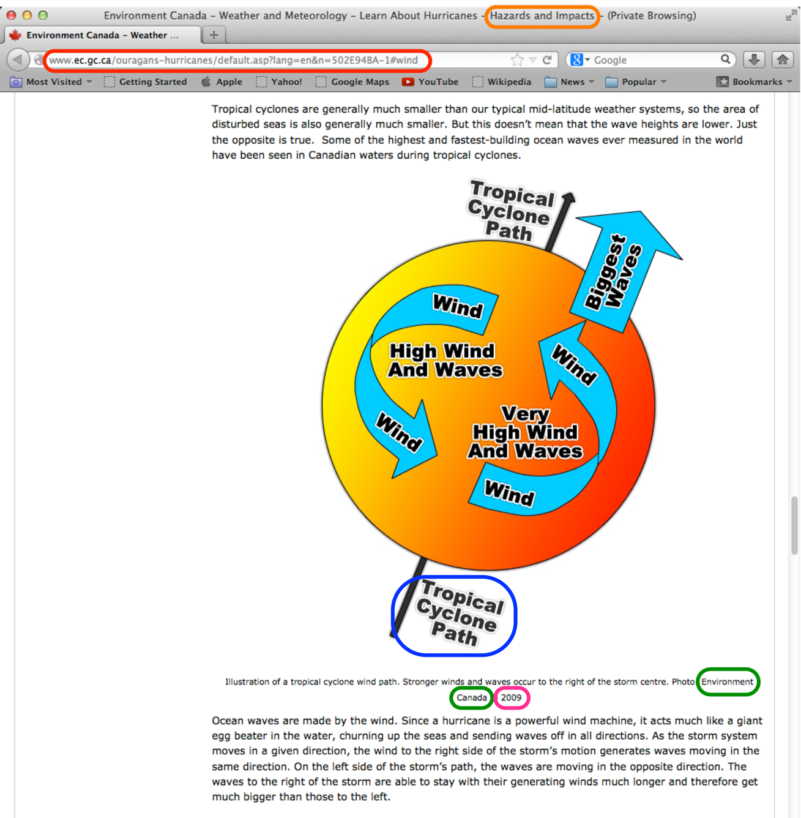

Environment Canada. "Tropical Cyclone Path." Diagram. 2009. Hazards and Impacts. Web. 31 May 2013. <http://www.ec.gc.ca/ouragans-hurricanes/default.asp?lang=en&n=502E94BA-1#wind>

Identify Bibliographic Information – eBook

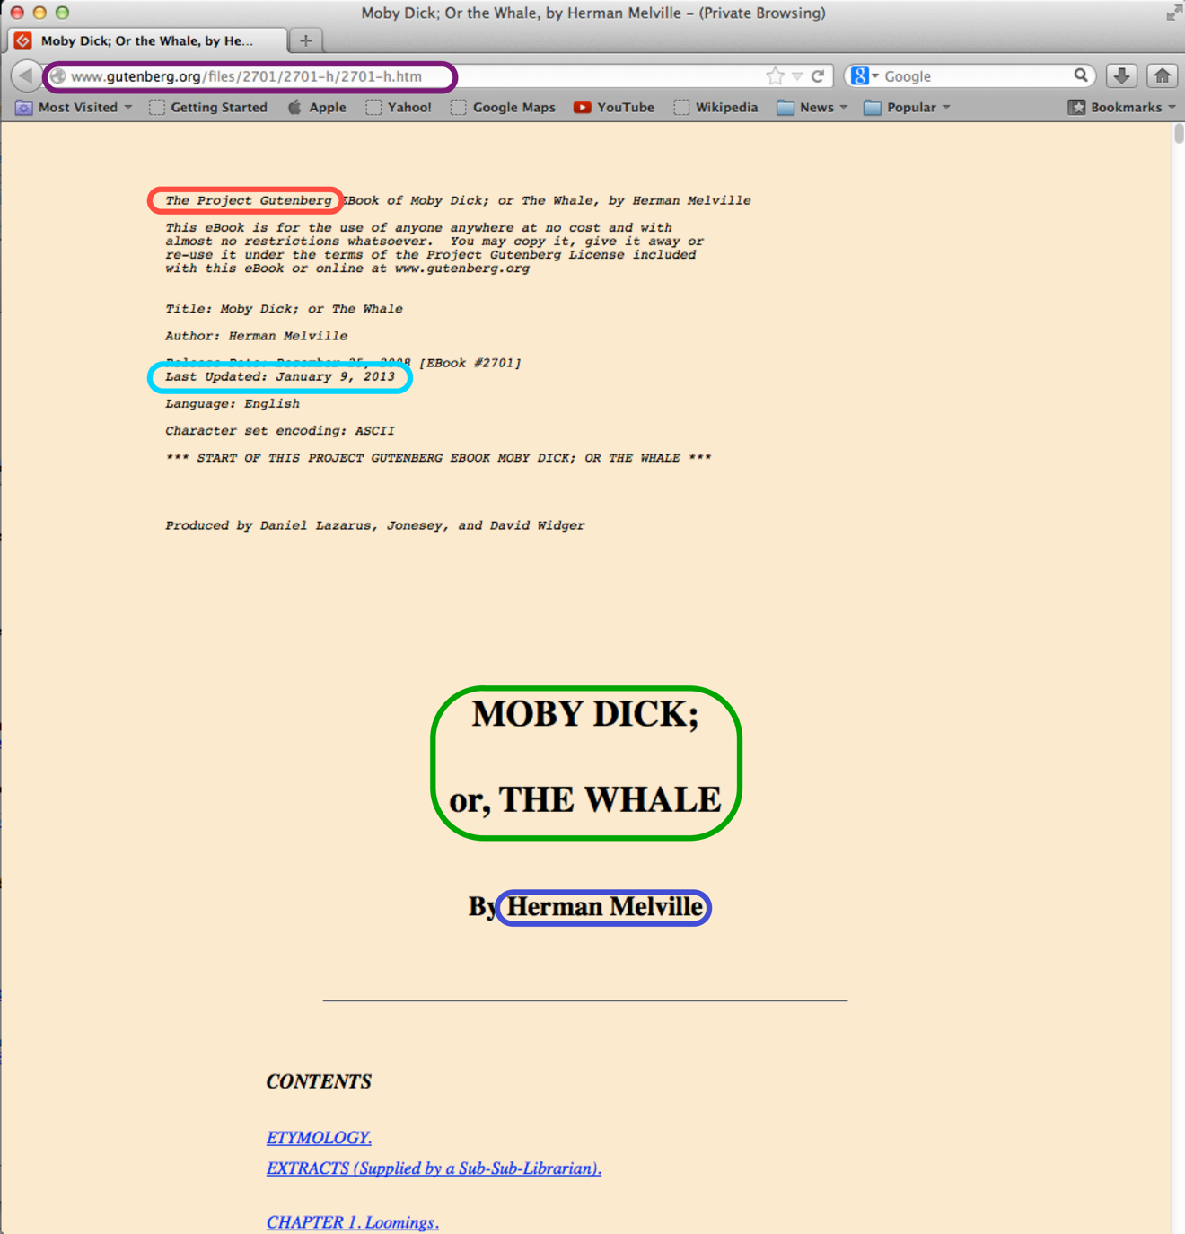

Melville, Herman. Moby Dick; or The Whale. Project Gutenberg, 2013. Html file. <http://www.gutenberg.org/files/2701/2701-h/2701-h.htm>

Identify Bibliographic Information – Encyclopedia

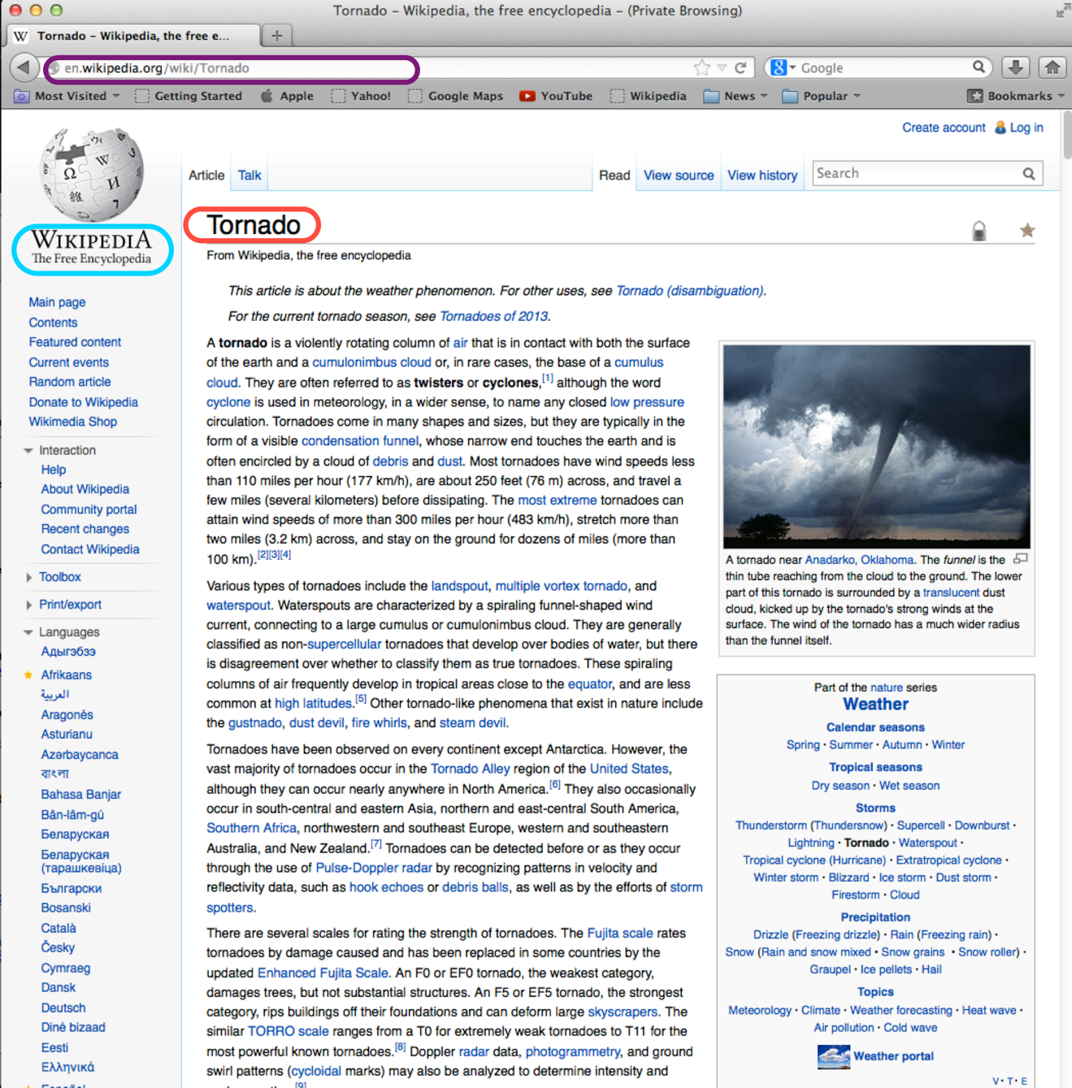

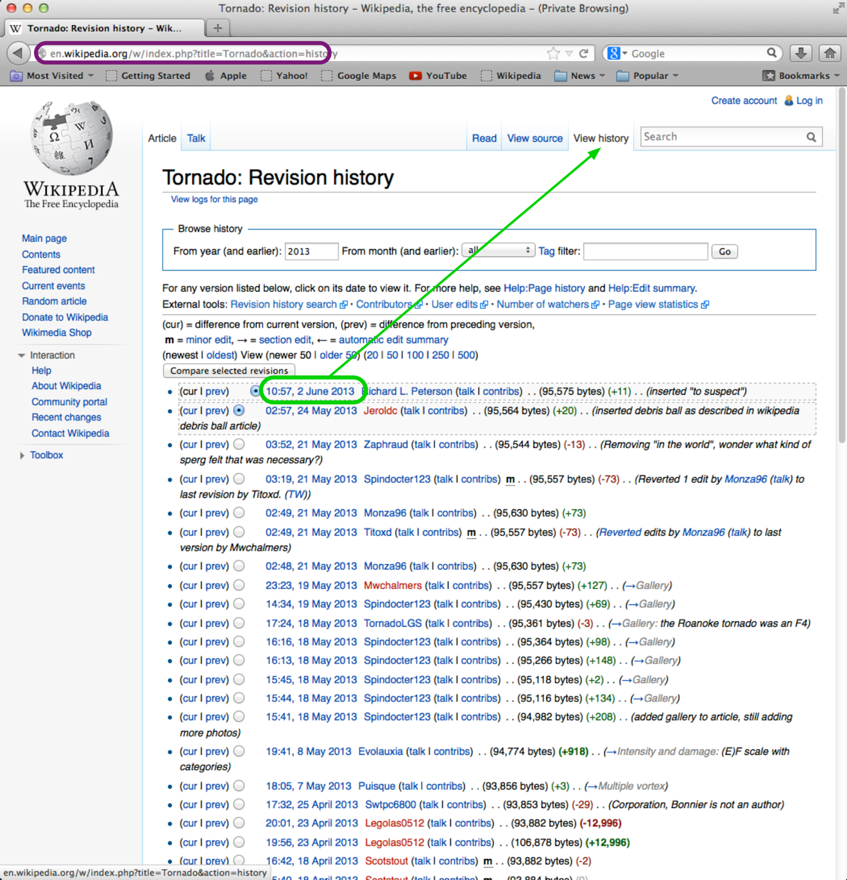

Wikipedia contributors. "Tornado." Wikipedia, The Free Encyclopedia, 2 June 2013. Web. 3 June 2013. <http://en.wikipedia.org/wiki/Tornado>

Identify Bibliographic Information – Image

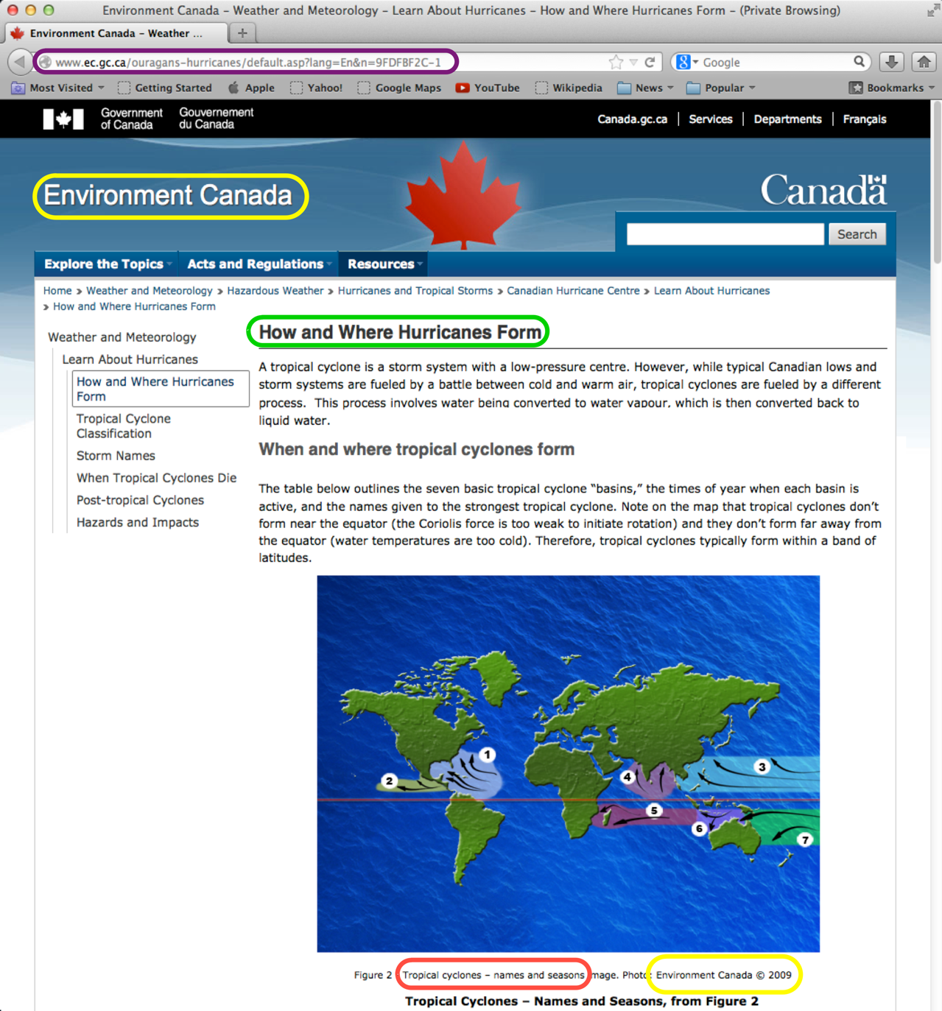

Environment Canada. "Tropical Cyclones: Names and Seasons." Photograph. 2009. How and Where Hurricanes Form. Web. 31 May 2013. <http://www.ec.gc.ca/ouragans-hurricanes/default.asp?lang=En&n=9FDFBF2C-1>

Identify Bibliographic Information – Web Page

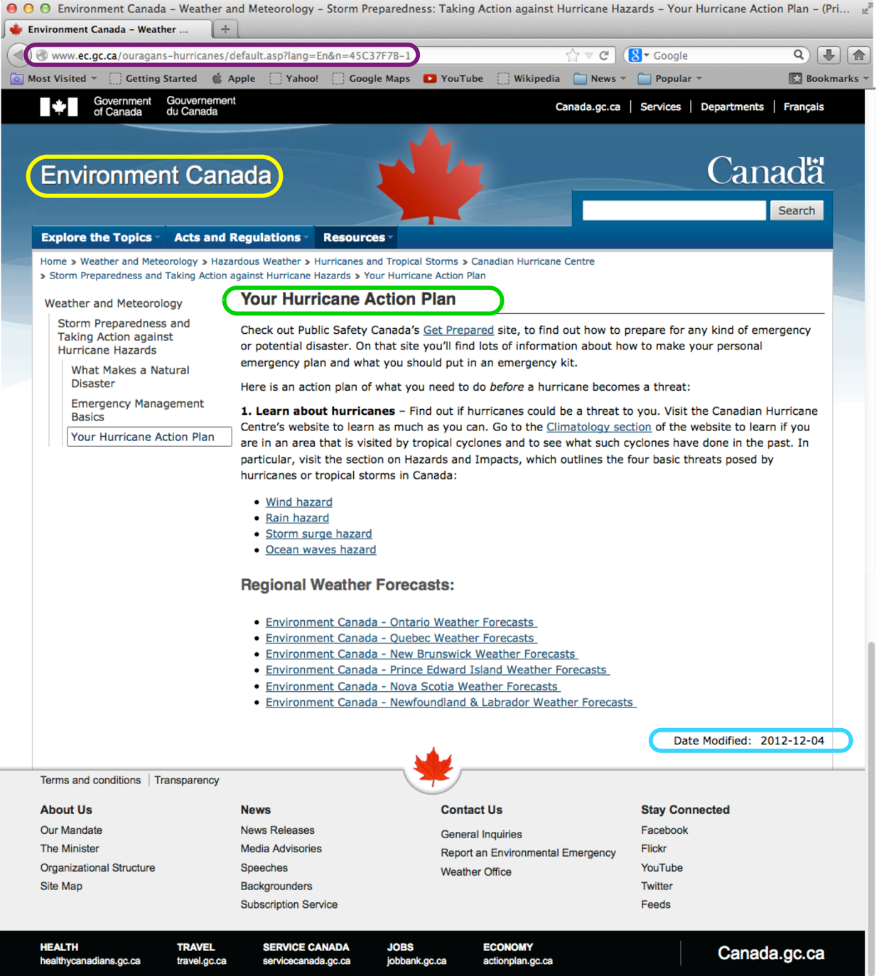

"Your Hurricane Action Plan." Environment Canada. 4 Dec. 2012. Web. 31 May 2013. <http://www.ec.gc.ca/ouragans-hurricanes/default.asp?lang=En&n=45C37F7B-1>

Works Cited

Environment Canada. "Tropical Cyclones: Names and Seasons." Photograph. 2009. How and Where Hurricanes Form. Web. 31 May 2013. <http://www.ec.gc.ca/ouragans-hurricanes/default.asp?lang=En&n=9FDFBF2C-1>
Environment Canada. "Tropical Cyclone Path." Diagram. 2009. Hazards and Impacts. Web. 31 May 2013. <http://www.ec.gc.ca/ouragans-hurricanes/default.asp?lang=en&n=502E94BA-1#wind>
Melville, Herman. Moby Dick; or The Whale. Project Gutenberg, 2013. Html file. <http://www.gutenberg.org/files/2701/2701-h/2701-h.htm>
Twain, Mark. The Adventures of Huckleberry Finn. New York: Harper & Brothers, 1912. Print.
Wikipedia contributors. "Tornado." Wikipedia, The Free Encyclopedia, 2 June 2013. Web. 3 June 2013. <http://en.wikipedia.org/wiki/Tornado>
"Your Hurricane Action Plan." Environment Canada. 4 Dec. 2012. Web. 31 May 2013. <http://www.ec.gc.ca/ouragans-hurricanes/default.asp?lang=En&n=45C37F7B-1>

