Inquiry Process: Deconstructing Webpage Addresses

The Uniform Resource Locator (URL) is the webpage’s “address” which can tell you about the source of the information that you’re viewing.

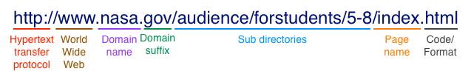
Hypertext Transfer Protocol: the letters “http” mean that the hypertext protocol is being used and that this item is a webpage from the World Wide Web. Often a “www” that appears at the beginning of the URL.

Domain Name: Person or organization that hosts the site. In this example, NASA is the organization that is hosting this webpage.

Domain suffix: This is the “.com” or “.ca” part of the web address. It can help you identify the type of organization or the associated location of the site. This is useful information about the site’s credibility that you can get at a quick glance.
Organization |  | Location
Domain Suffix | Meaning | Domain Suffix | Meaning
.biz | Business | .au | Australia
.com | Commercial | .be | Belgium
.edu | Education | .ca | Canada
.gc | Government of Canada | .es | Spain
.gov | Government | .fr | France
.info | Information Source | .gb | Great Britain
.mobi | For Mobile Phones | .ie | Ireland
.mil | U.S. Military | .mx | Mexico
.net | Network | .nz | New Zealand
.org | Organization | .uk | United Kingdom
.tv | Television | .us | United States
With the exception of .edu, .gov, and .mil, these domain suffixes can be registered by anyone. The domain suffix can provide useful information, but you should still be vigilant with the information you find on websites.

Sub directories: Large web sites are often organized with subdirectories. The web address maps out the particular subdirectories that lead to the page you’re viewing.

Name of the page: The name of the page will appear at the end of the web address. Well-organized sites will name their pages something logical and relevant to the content of the page.

Code/Format: the last bit of the web address is usually the code or format that the page has been created in. Some common ones are “.html”, “.php”, or “.pdf”. If you are on the index (main page) of the site or subdirectory, this may not be visible in the web address.

