Inquiry Process: Natural Disasters

Your Task
Over the next few weeks you will be preparing to film a newscast about a natural disaster of your choice. The groups will be composed of four members. You will choose which of the following natural disasters you wish to cover:

Blizzard | Hurricane
Earthquake | Tornado

The newscast will take place in Montreal. Thus, you must be aware of how the disaster you choose would affect not only the Montreal area, but also what global effects it may have.

Group Roles
Each group will choose which role they wish to play in the newscast. The four roles that are expected in your newscast are:
- An anchorperson is a television reporter who coordinates a broadcast to which several correspondents contribute.  - An eyewitness is a person who has seen someone or something and can bear witness to the fact.  - A meteorologist is someone who reports and forecasts weather conditions.  - A field worker is someone who has done work or firsthand observations made in the field as opposed to in a controlled environment. | 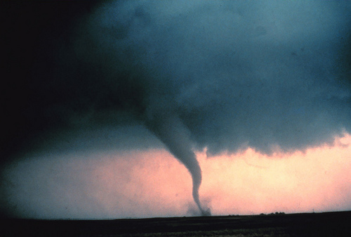
 | Image by: National Oceanic and Atmospheric Administration (NOAA)
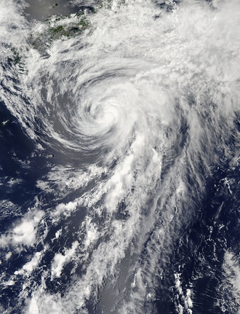
Group role responsibility: Each group member will be responsible for researching one Little Question pertaining to his or her chosen role. IS-21 will be used to conduct individual research.

Getting Started
You will visit a station for each of the four natural disasters. As you visit each station, explore all the materials provided. Have fun! Discuss as a group which disaster you are most interested in choosing. Once you have chosen, log in to IS-21 through the portal and complete the START step for your task.

Image by: NASA Goddard Space Flight Center

