Using Stations/Centres in the Class

Teacher Preparation
- Choose an ABRA or READS story.
- Set up 4-5 stations in the classroom with varied activities (7-8 learners/station).
- Prepare each station (paper, printables, crayons, other materials needed, etc.).
- Write out a specific set of instructions for each station – see below for help.

Suggested station activities:

Using printables, including worksheets, sequencing cards, etc. (from ABRA Teacher Zone or other prepared materials)
- On a table have various printed materials that learners can choose from.
- Ask learners to choose one and complete.

Colouring pictures and images
- On a table have various colouring pages that learners can choose from.
- Ask learners to choose one and complete.

Listening station
- Set up a chosen ABRA story that learners can listen to.
- Use laptops and headphones (if available in the classroom; if not can be done in the lab) taking turns.
- Learners listen to the chosen story.

Echo reading (See Echo Reading: Tips for Success Teacher Aid)
- Use the printed PDF of the story.
- Sit at a table or on the floor with learners (preferably facing one another in a circle).
- If the teacher is not available to conduct the activity, ask a facilitator to begin reading the story.
- Learners read the story taking turns (i.e. continuing where the last person left off).

Painting/Drawing
- Facilitator sets up a station with paints/markers/crayons and paper.
- Learners can paint or draw their favourite part of the story.

Writing
- Facilitator sets up a station with lined paper and pencils.
- Learners write a new story ending.
- Learners use vocabulary from the story and write 2-3 complete sentences.
Filling in the blank spaces
- Create 3-4 sentences using the story content with blank spaces.
- Make sufficient copies of sentences.
- Set up a station with copies of fill-in-the-blanks sentences.
- Learners take one sheet each and complete.

Rewriting story in own words
- Facilitator sets up a station with paper and pencils.
- Ask learners to write a summary of the story.
- Remind them to consider: characters, main events, conclusion.

Paper Puppet Making
- Facilitator sets up a station with craft, colouring and other relevant materials available.
- Ask learners to create a small paper puppet.
- Remind them to consider: characters, main events, conclusion.

Dramatizing (role play)
- Facilitator sets up a station with props or puppets if available.
- Learners discuss and choose a favourite scene/part from the story.
- Learners choose a character from the story that they will play.
- Learners act out one scene/part form the story they agree on.

Retelling the story in own words (See CL Lesson Plan: Literary Circles)
- Learners at this station sit together in a circle with a discussion leader.
- Learners take turns retelling various parts of the story.
- Discussion leader can decide if this should be done as a sequencing or summarizing activity.

Question and Answer
- Create 4-5 short questions about the story.
- Make sufficient copies of questions.
- Set up a station with your questions sheet and pencils.
- Learners take one sheet and complete the questions.

Learner Preparation
- Have learners come to the mat.
- Read the ABRA story (use projector and iBook or a PDF copy of the story if available or simply summarize it).
- Provide an overview of the activities available at the different stations.

Using the Stations
- Put learners into groups of 6-8 and assign them to an initial station.
- Use visual cues to help learners identify stations easily. (See following pages for visual cue cards.)
- Make sure to indicate the time needed for each station’s activity. (Suggest 10-25 mins. for a total class time of 90 mins.)
- Learners should rotate through the stations--set one way of rotating, i.e. clockwise or anti-clockwise.
- If time does not allow for completion of activity (i.e., role-play, literary circle, echo reading), learners can start at that station upon the next rotation
- Supervise learners as they rotate through stations and do the activities.
- Rotation can be done by alerting learners using:
- Bell.
- Clapping of hands.
- Using gestures.
- Word of mouth.

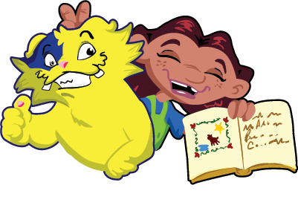  Echo Reading | 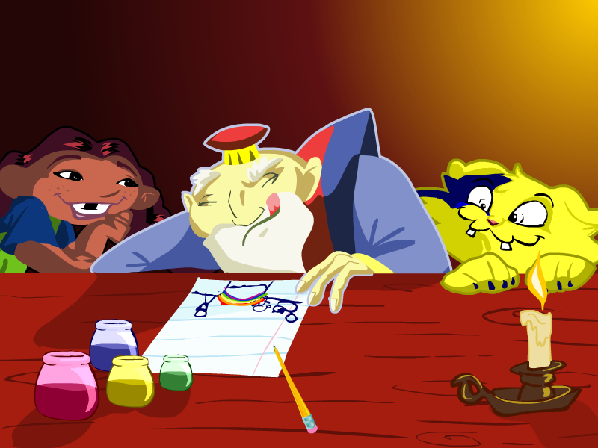  Drawing
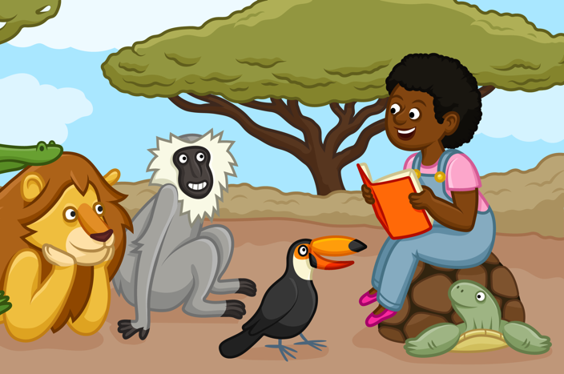  Listening Station | 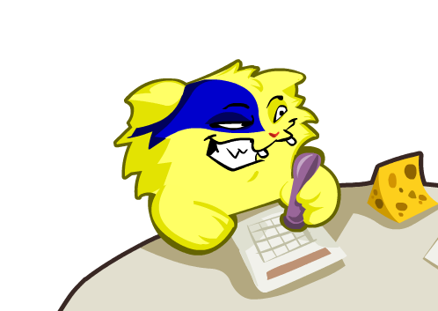  Writing
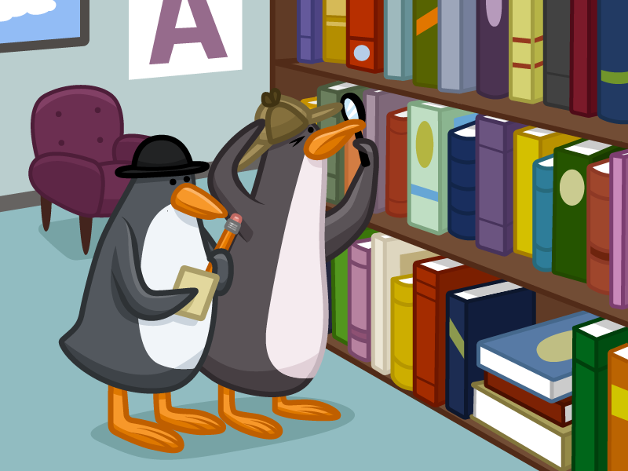  Q&A | 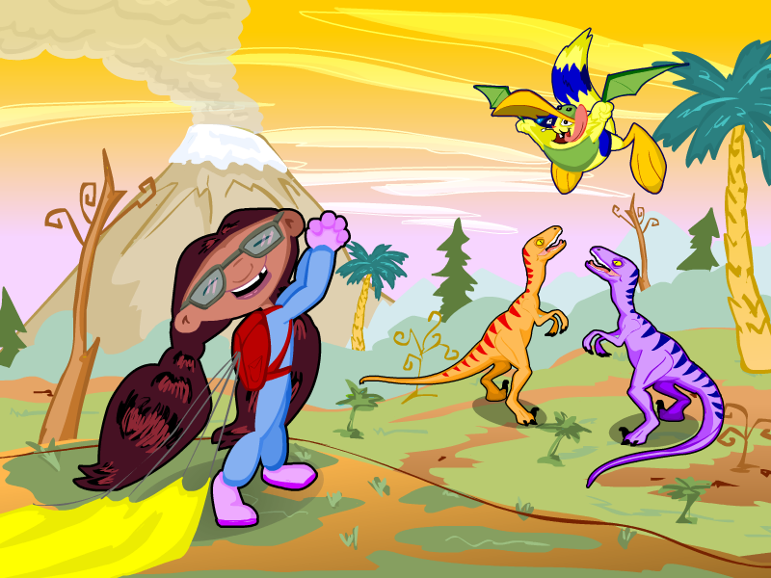  Five Finger Retell
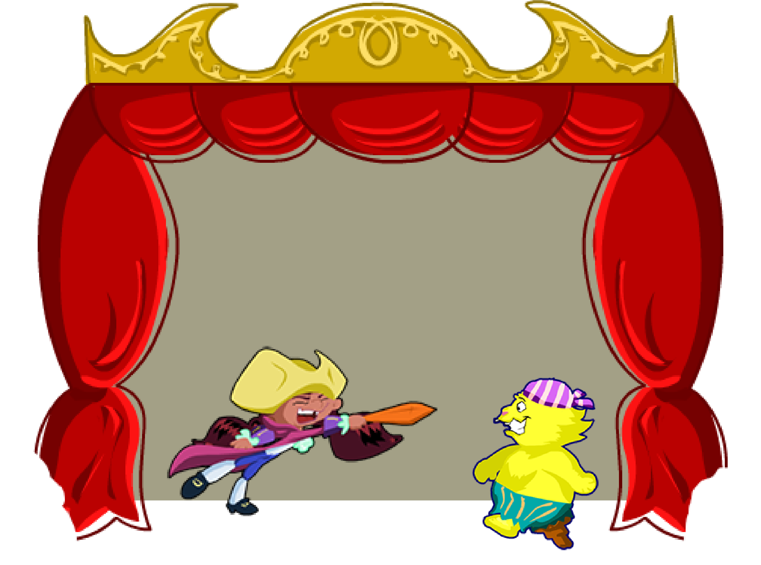  Role Play | 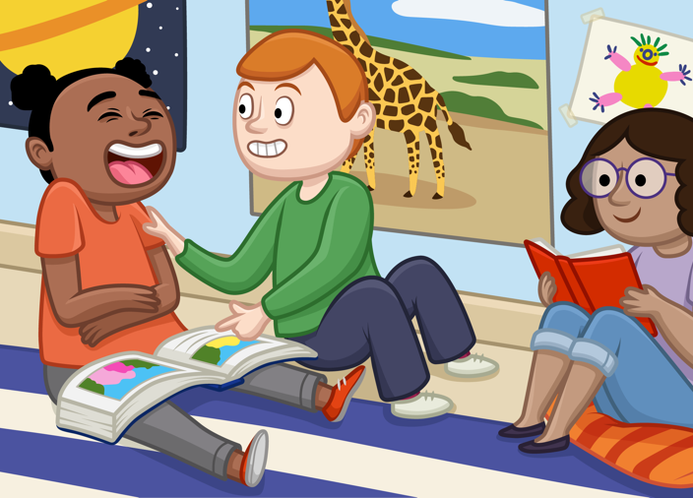Literary Circle
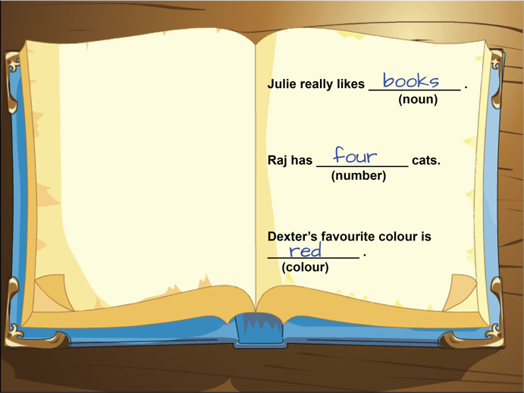Fill in the Blank | 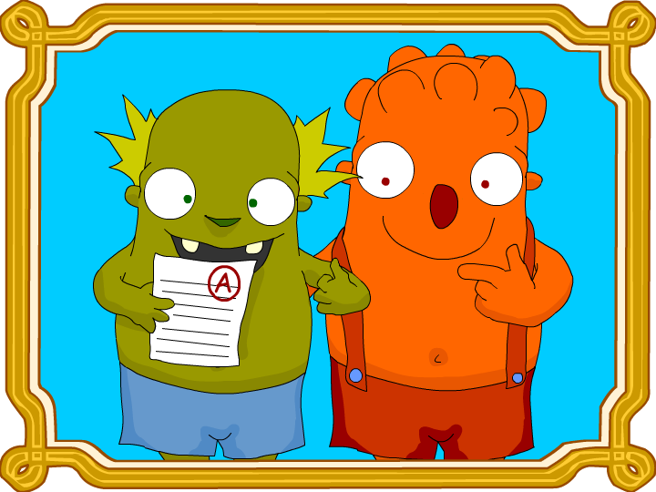Worksheets

