Tracking Learner Activity with ABRA

This Teacher Aid will help make the most of ABRA’s learner tracking features starting with the log-in process, which is essential for correctly tracking learner work.

How Does the ABRACADABRA Log In Process Work?
At the beginning of the school term, class names, teacher names, and learner names (connected to a class) must be entered into the software. The School Administrator usually does this.

- A User ID and password is created for each teacher.
- A User ID and password is created for each learner.
- A User ID and password must be used when logging into the software.
Tip: make sure each learner signs in to their own account to ensure their time in ABRA is correctly tracked.

Changing Passwords in Teacher Accounts
A teacher can change his/her own password at any time. To do this, access the software using your login credentials.
- Click on the Manage button.
- Click on the My Account button.
- Enter your old password.
- Enter a new password. It will have to be entered twice.

Teacher accounts also have the capability of changing learner passwords.
- Click on the Manage button.
- Click on the My Students button.
- Click on the Pencil icon next to the learner’s name.
- Change the password in the Password textbox.
- Click on the Save & Close button.

What Learner Data is Tracked?
ABRA tracks the following data on learner use:
- The amount of time the learner has used ABRA within a session.
- The activities that were consulted (and the number of times they were consulted).
- When the learner went for support (i.e. clicking on a word in the Tracking activity).
- When the learner made an error (i.e. incorrectly spelling a word in the Spelling activity).

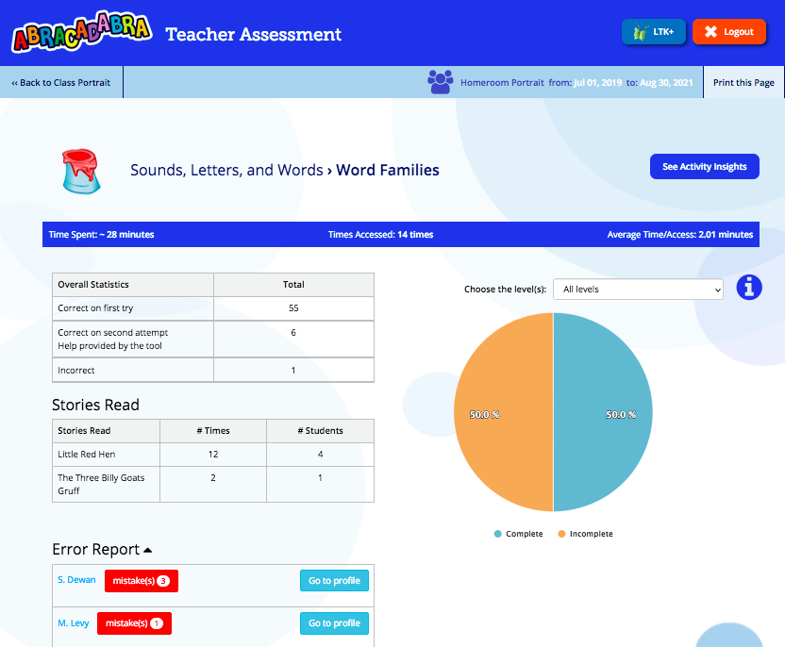
What Assessment Reports are Available?
Teachers are able to access a report of ABRA activity by:
- Whole class
- Individual

To access these reports, click on the cog icon from the Lobby Page.

Here is an example of a whole class report, focusing on the Word Families Activity.

This information helps teachers
understand the type of errors their learners are so they can determine ways to help them.

How do Teachers use the Information Provided in an Assessment Report?
Teachers can:
- Use the time spent information to decide whether learners are going through a story or activity too quickly.
- Look at the list of words clicked on to see what type of word families learners or the class is struggling with and spend more time with struggling learners.
- Encourage learners to return to a story and/or activity that was completed too quickly or needs to be practiced again.
- Encourage learners to click on words they don’t understand and use the help provided.
- Design whole class writing activities using words the class is struggling with (word families).

Ensure learners have completed the assigned activities.

