Different Learners/Different Needs

Using ABRACADABRA in a Mixed-Ability Classroom
Children vary in their ability to do certain kinds of schoolwork. Some need more assistance, attention, and time from the teacher. To use ABRA successfully in your class, here are some ideas for working with mixed-ability groups:
- Depending on the lesson objectives, teachers might want to group learners according to abilities.
- Learners who need more time and attention (we call them “children with special needs”) benefit from having 1 computer or 1 book each.
- Let the special needs learners read simple stories or try simple activities (e.g.: alphabetics) from Level 1 in ABRA.
- Ask other learners to work on their own while the teacher assist the special needs learners.
- During free time (break/lunch), use the laptop to help the special needs learners and give the rest of the class other activities such as drawing and colouring, worksheets, writing simple sentences, or making/forming words using letters.
- Give learners with stronger computer skills or a better understanding of ABRA a chance to assist learners who need more help. This fosters self-esteem and confidence, as well as a sense of cooperation and collaboration.
- Create experts in your classroom. Identify learners who have an excellent understanding of how computers/tools/software function. Make these learners the “helpers” for the class. Make a sign in the lab that is visible to all learners, so when someone struggles, they can go to:
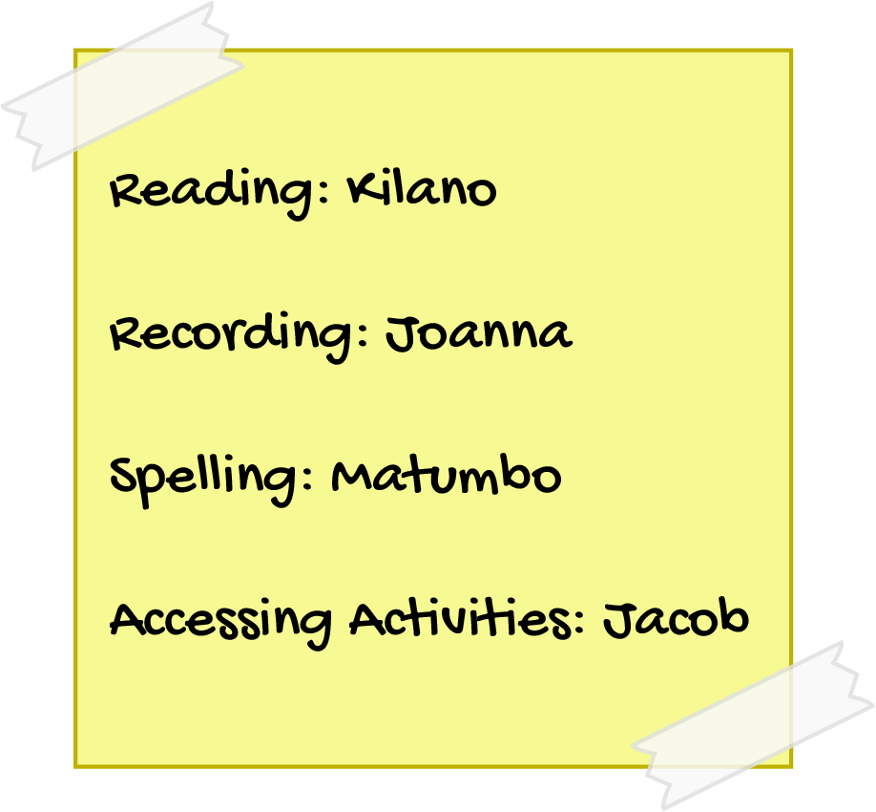
- Try having peers teach each other by pairing stronger and weaker learners to work on an assignment.

