Gender Equity in the Classroom

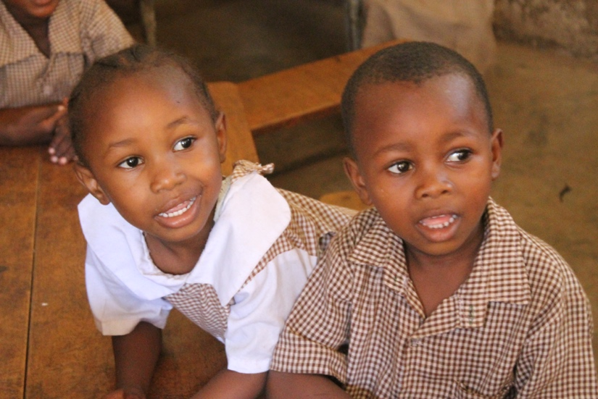
Success for every learner is a common teaching goal. However, the attitudes about gender held by teachers, staff, learners, and parents can create a school environment where girls receive unequal treatment, are held to different (lower) standards, and end up with fewer opportunities in life.

To combat this, it is important to promote gender equity in classrooms and schools. Gender equity means the process of being fair to both girls and boys. Gender equity may require teachers, staff, parents, and learners to examine their assumptions and ideas about the behaviours, interests, and abilities of girls and boys.

Ensuring gender equity is an ongoing process that touches:

Curriculum Materials and Lesson Plans
- What images of girls and boys (women and men) are portrayed in textbooks and other materials? Are men shown as leaders while women are in the background? Are all the scientists and doctors men?
- Examine and discuss these issues with your learners.

Questions in Class
- It is not uncommon for girls to hesitate or hold back from answering a question asked to the whole class.
- Instead of calling on the most eager learners, given everyone a few minutes to think of an answer.
- Challenge all learners, not just boys, with questions or problems that require effort and time to answer/solve.
- Try having learners work in smaller groups, especially if you incorporate cooperative learning techniques (See handout).

Language and Stereotypes
- It’s quite easy to slip in general comments about girls and boys such as “all girls are quiet” or “boys like to make more noise.” However, these stereotypes can lead to false assumptions about learners’ interests and abilities. Try to treat each learner as an individual.
- Identify and discuss with your learners how boys and girls are referred to in the community, at school, or at home. Are these terms negative or positive? What might be the impact of this language on learners?

Tasks and Responsibilities
- Ensure that girls and boys are responsible for different classroom tasks and responsibilities, whether those are being the leader of a group or the person who cleans the blackboard.
- When using computers or science lab equipment, make sure the girls are using them as often as the boys. Don’t let stereotypes about math and sciences being “for boys” get in the way of everyone’s learning in these important areas.
- Conversely, when working on reading and writing (often seen as more feminine), ensure the boys participate equally.

So, what does the gender equitable classroom look like? It is any classroom, large or small, where:
- The curriculum reflects the needs and experiences of both girls and boys.
- The teacher has analyzed her/his potential biases about gender and when addressing class, is careful to use gender-neutral language.
- All learners feel comfortable participating in subjects (i.e. math and science if girls, literature if boys).
- Class materials, to the extent possible, reflect girls and boys in all different contexts and ways. If not--for example, if photos show boys as always being leaders--the learners discuss this and analyze it.
- Activities inside and outside the class promote equal participation and enjoyment by both girls and boys.

